# **Korzo - Work Flow**

## 

## **Product Configuration**

**Product Category:**

* Curtain
* Fabric
* Track
* Motor
* Roller

**1. Curtain:**

* The curtain product configuration has already been documented.

Refer: [Curtain Product Configuration Details](https://docs.google.com/document/d/1gM0LsOGTXZTiIlESsLBV_GXDeIKlinrJsHE8MhDkkd8/edit?usp=sharing)

**2. Fabric:**

* In the fabric product configuration, you need to specify the **width**.

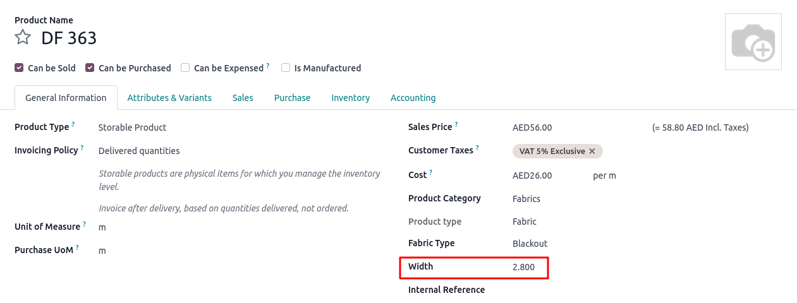

* This width is essential for calculating **Fabrics Count** in the sale order.

**3. Roller, Fabric, Track, Motor:**

**Vendor information:**

* Each of these products must include **vendor information** to enable automated purchase processes.

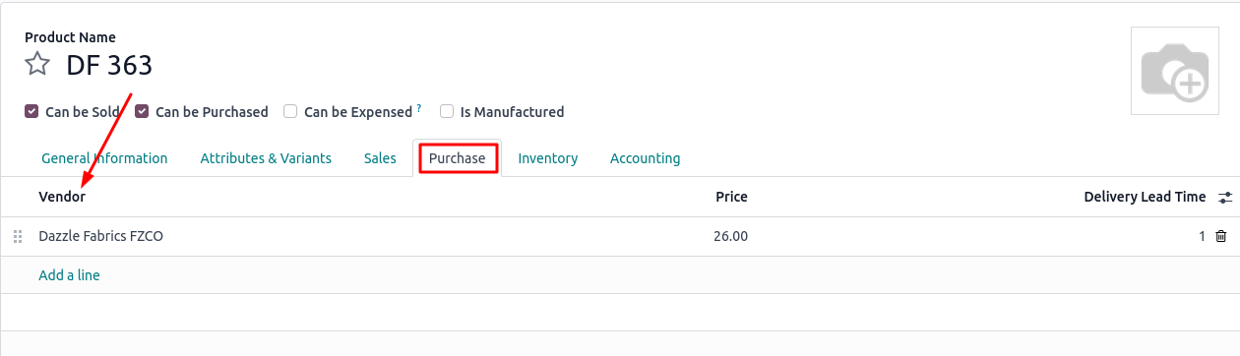

* When a sale order is confirmed, the system should automatically generate a **purchase order**.
* To enable this, each product must have vendor details (e.g., vendor name, price) configured in its product form.

**Routes Configuration:**

* Each of these products must have the “**Buy**” and “**Replenish on Order (MTO)**” routes enabled to support automated purchase order creation when a sale order is confirmed.

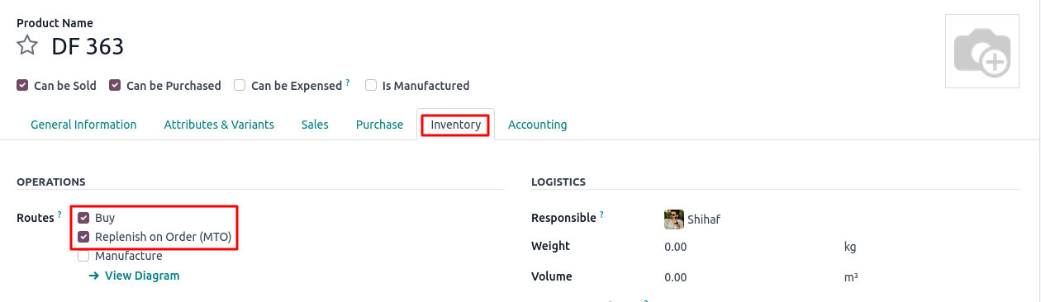

## 

## **Curtain Type Configuration**

These are the available **types of curtains** in the system:

* American
* Wave
* Eyelet
* Roman
* Motorised American
* Motorised Wave

Each curtain type is managed under the “**Curtain Type**” menu and includes the following configuration:

Height and Width Adjustment Factor:

* Used to calculate the **Fabrics Count** in the sale order.

Cost Price:

* Used to calculate the **Unit Price** in the sale order.

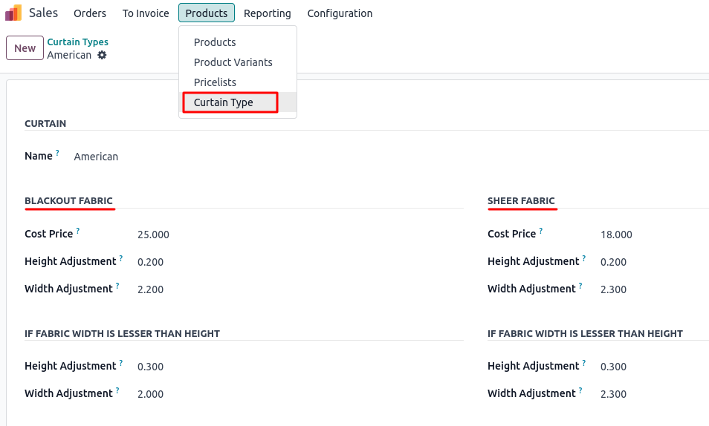

## 

## **Sale Order Process**

**Product Type:**

The following product types can be added to sale order lines:

| **Curtain** | **Blackout & Sheer** | **Roller** | **Other** |
| --- | --- | --- | --- |
| Main Curtain | Main Curtain | Main Roller | Service |
| Fabric Product | Blackout Fabric  Sheer Fabric | Fabric Product | - |
| Track Product | Blackout Track  Sheer Track | - | - |
| Motor (if required) | Blackout Motor  Sheer Motor  (if required) | - | - |

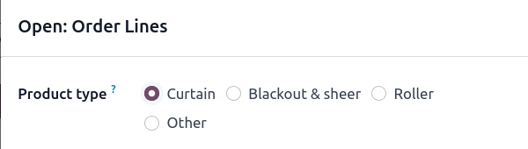

**Sale order Line:**

* On the **sales order**, the user will select the **main curtain product** (with a *kit-type BOM*).
* Additional components such as
* Fabric product
* Track product
* Motor (If required)
* will also be added to the sales order lines.

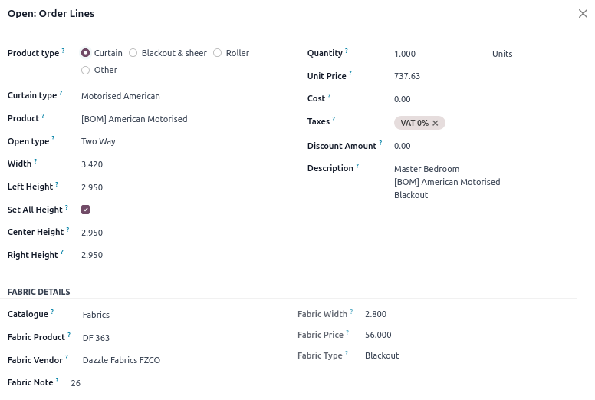

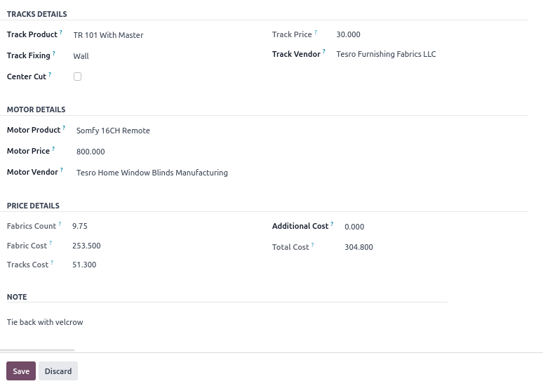

**Purchase Order Creation:**

* After confirming the sale order, you will see **“Purchase”** smart buttons at the top**.**

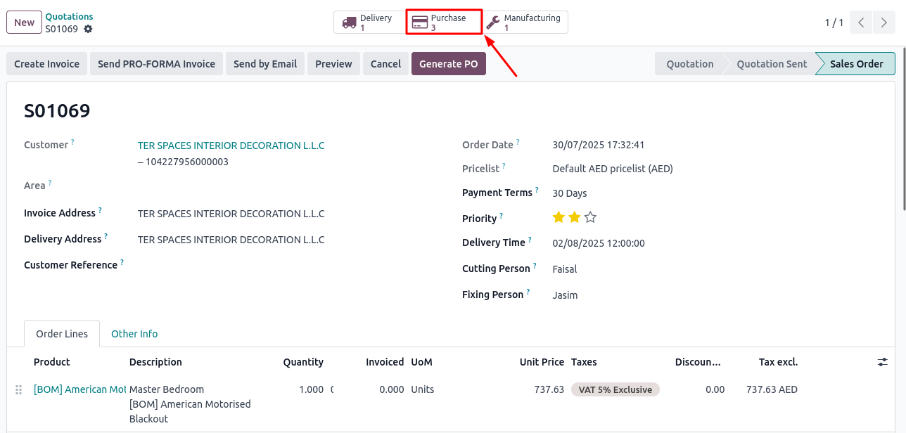

* Click the **Purchase** smart button to view the automatically generated purchase orders.

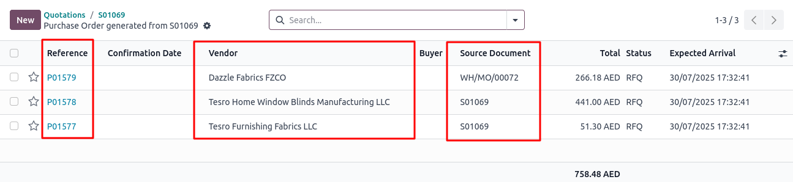

* Purchase orders are created **separately for each vendor** based on the products and their configured vendor information.
* The **purchase order** will include the **fabric product**, **track product**, and **motor product** that were selected in the **sale order line**.

Note:

* **Track**, **Motor**, and **Roller** product purchase orders are used for the **Sale Order Delivery**.
* In contrast, **Fabric** product purchase orders are used in the **Fabric Cutting** process.

Track product purchase order:

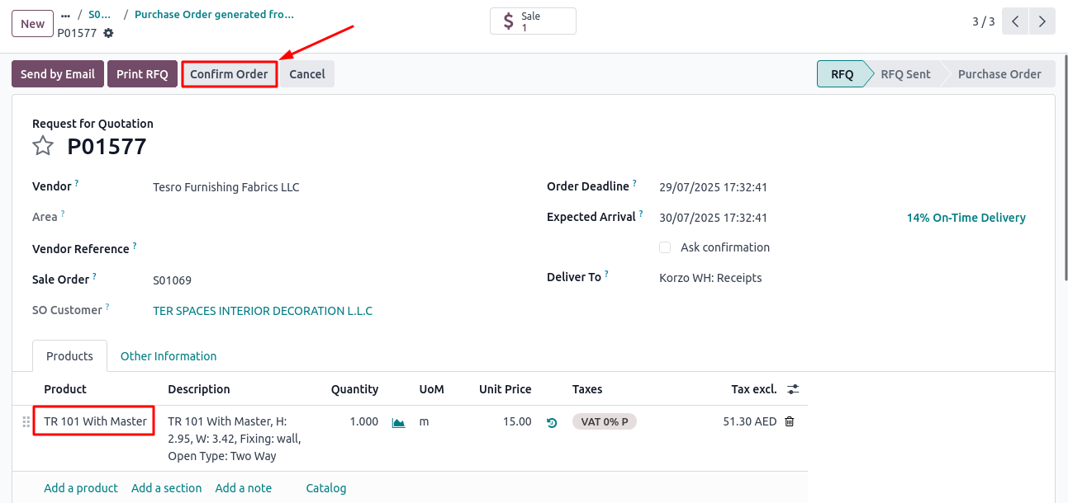

Fabric product purchase order:

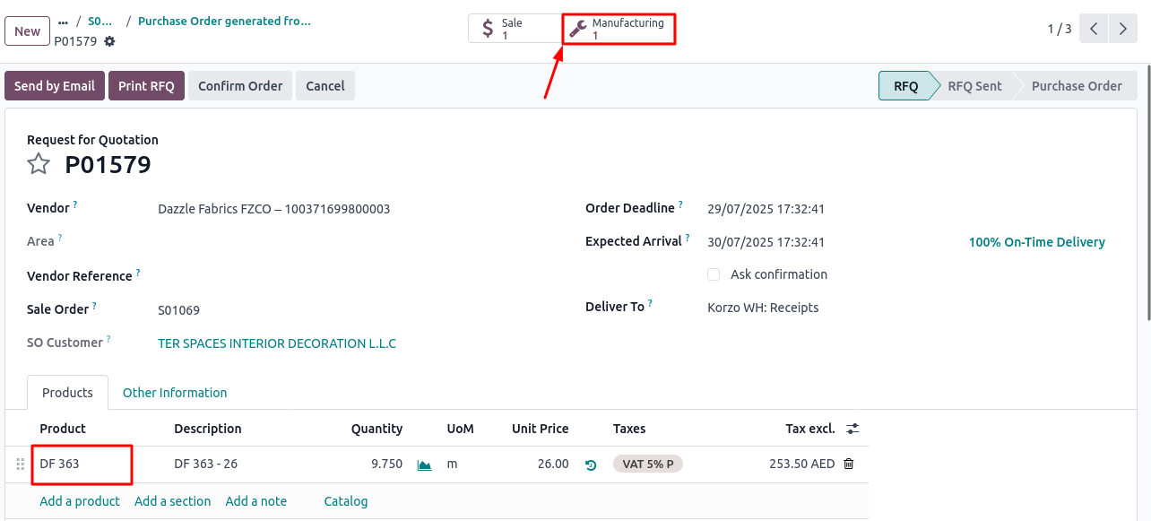

* You will see a **Manufacturing** smart button, which allows you to verify that the **purchased products** (specifically fabric) are being used in the **Fabric Cutting** app.

Note:

* In cases where the **same product** appears in **multiple sale order lines**, the purchase order will create **separate order lines** corresponding to each sale order line.
* E.g.

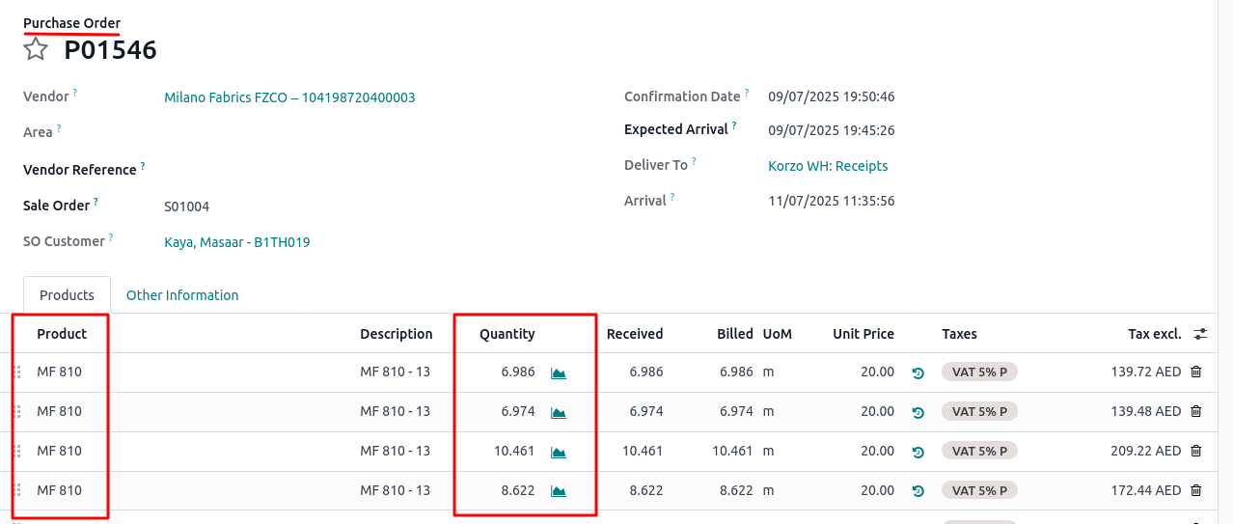

**Receipt App:**

* After confirming the purchase order, its corresponding **receipt** will be visible in the **“Receipts”** app.

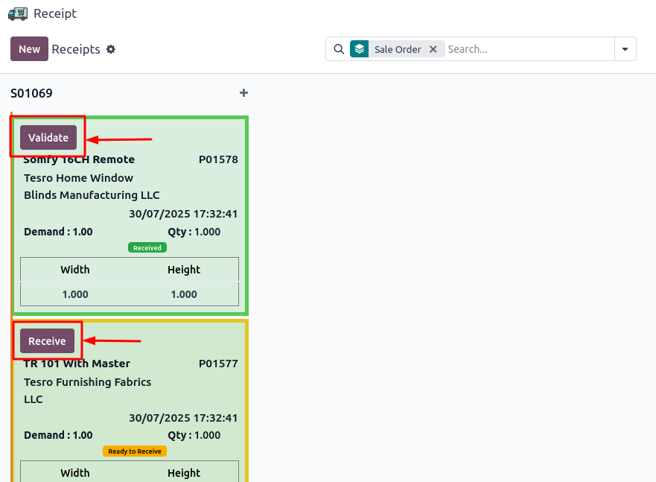

* In the **Receipt** app, you must first click **“Receive”**, and then **“Validate”** the receipt to confirm that the products have been received.

**Manufacture Order Creation:**

* The **fabric cutting operation** is managed in the **Fabric Cutting** app.
* After confirming the sale order, you can view the corresponding **fabric cutting order** within this app.

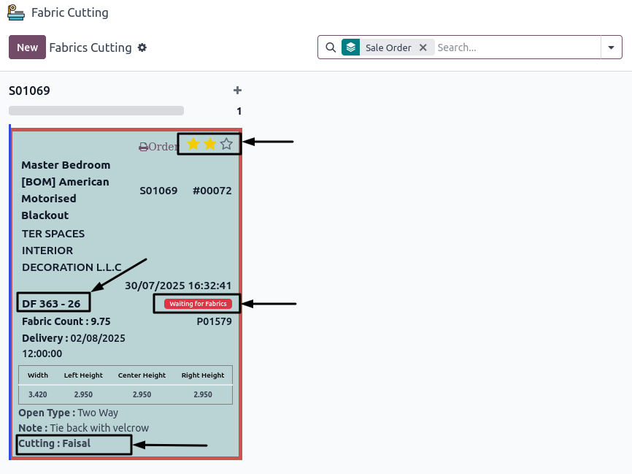

* The **fabric cutting operation** will include the **fabric product (DF 363 - 26)** that was selected in the sales order line as a component.
* You can also view the assigned **Cutting Person** and **Priority**, which are set during the creation of the **Sale Order**.

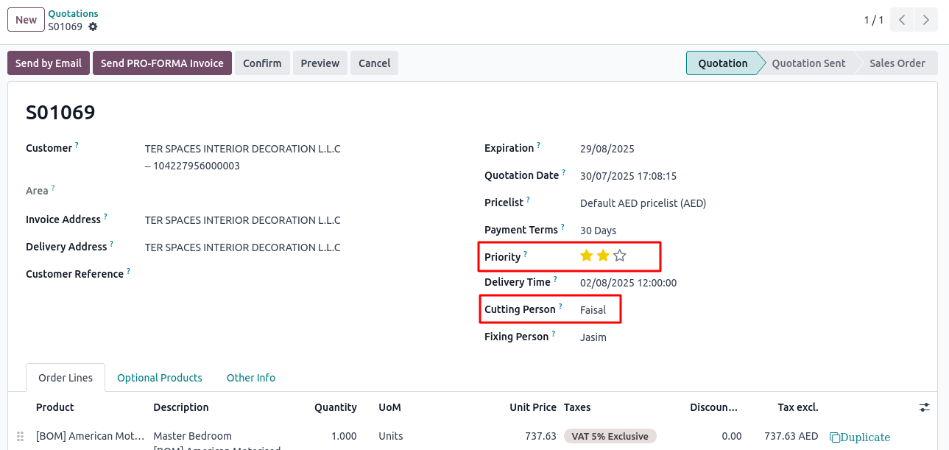

* If the fabric product has not been received, the fabric status will show **“Waiting for Fabric.”**

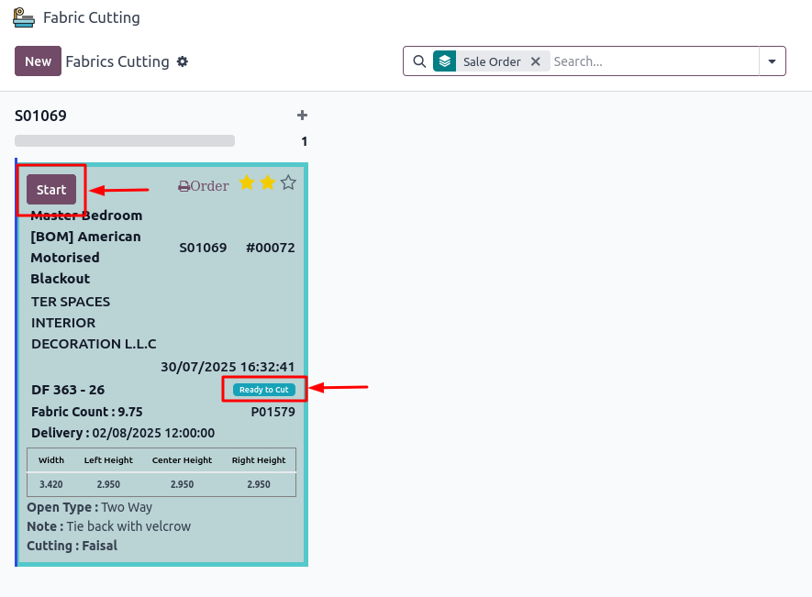

* After the f**abric is received,** the status will change to **“Ready to Cut”**, and the **Start** button will become visible.
* Once you click the **Start** button, two additional buttons will appear: **Push and Done.**
* **Push** – Used to mark partial progress, When clicked, the status will change to **“In Progress”**.

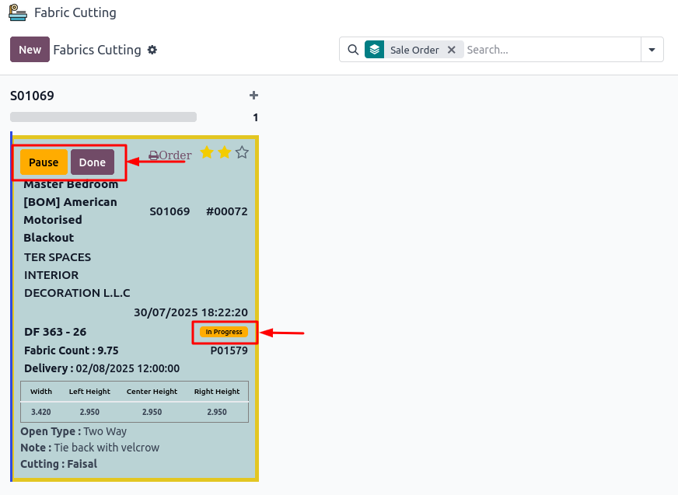

* **Done** – Used to mark the cutting operation as fully completed. When clicked, the status will change to **“Fabric Ready”**.

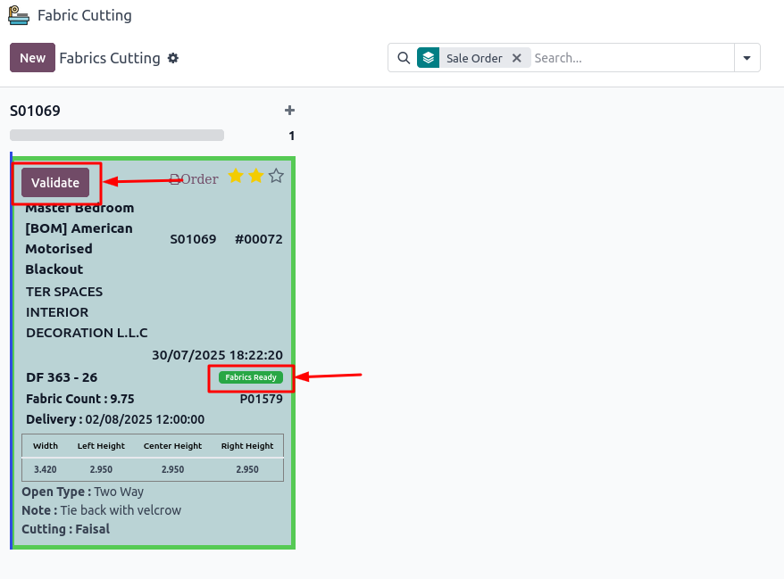

* After clicking the **Done** button, the **Validate** button will become visible.
* When you **validate** the fabric cutting operation, the **main product** (e.g., **“American Motorised”**) will appear in the **Delivery** app.

**Delivery Order:**

* If any required operation (such as receipt or cutting) is not completed, the products will **not appear** in the delivery order.
* After completing both the **receipt** and the **fabric cutting operation**, you will see the following products in the **Delivery** app:
* Main Product (e.g., Curtain)
* Track Product
* Motor Product (if required)

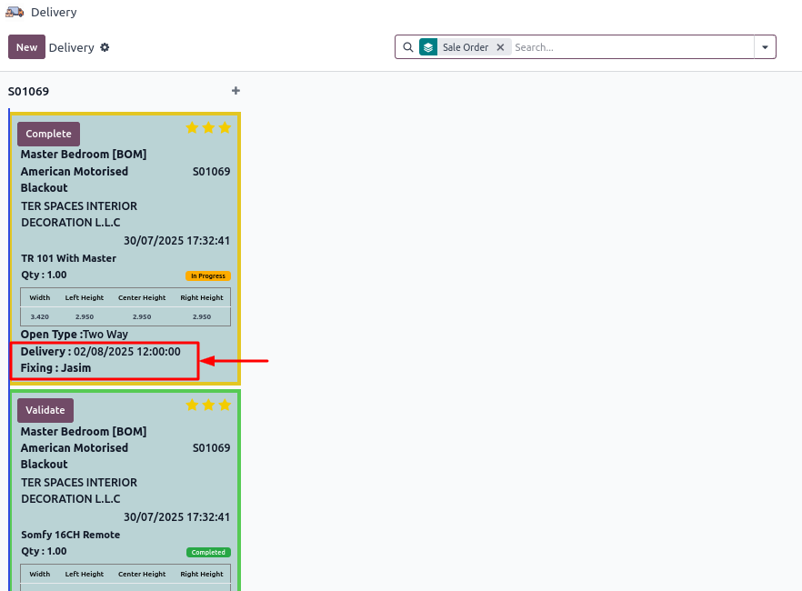

* In the **Delivery**, you can also see the **Fixing Person** and **Delivery Date**, which are set at the time of creating the **Sale Order**.

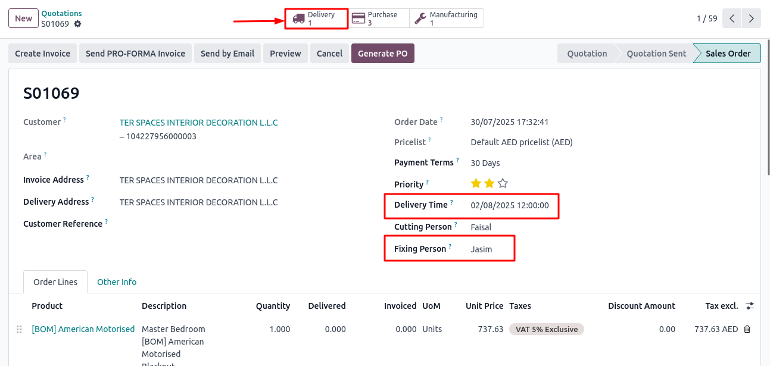

* You can also manage the **delivery priority** either directly in the **“Delivery”** app or through the **“Delivery** **smart”** button on the **Sale Order**.

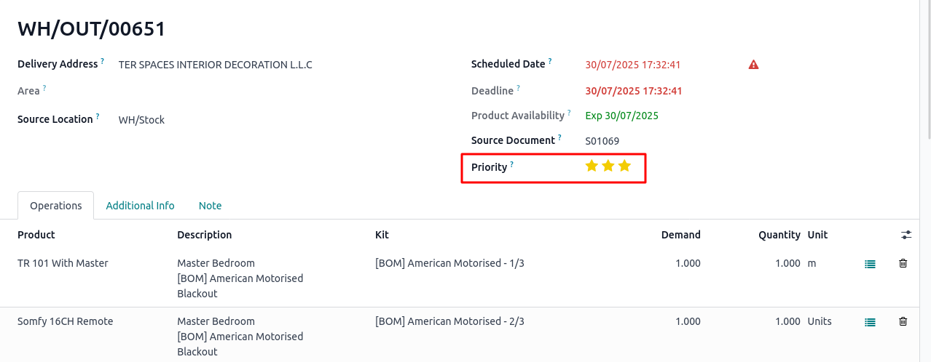

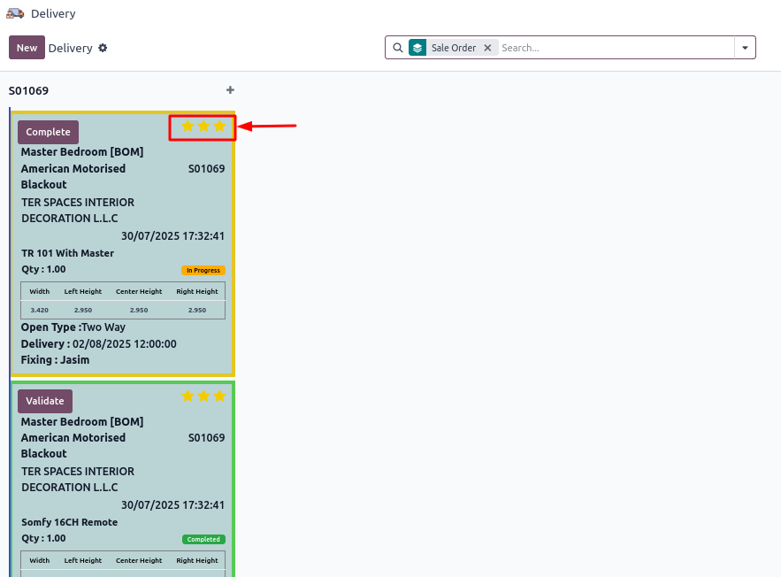

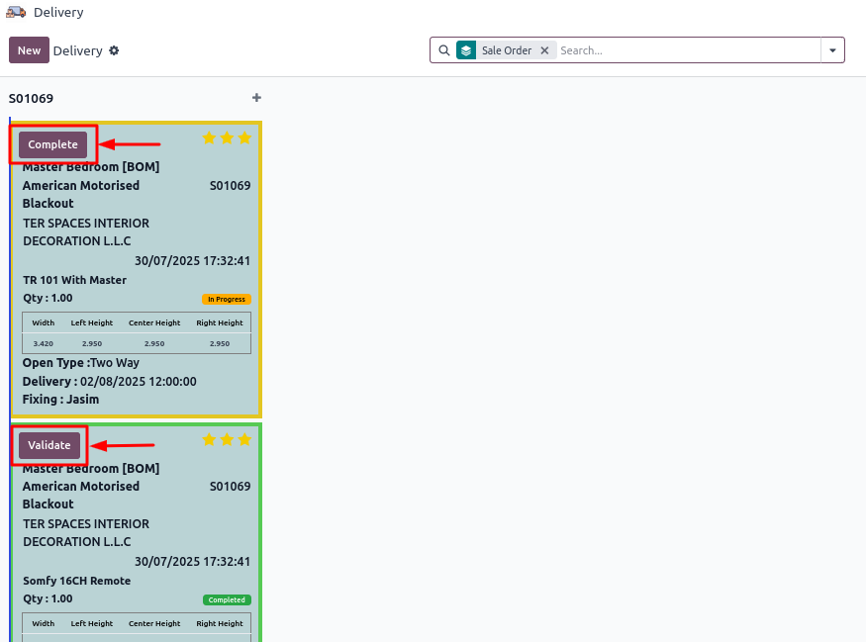

* In the **Delivery** app, you must first click **“Complete”**, and then click **“Validate”** to confirm that the products have been delivered.

**Note:**

* The product type **“Roller”** includes fabric, but it does **not require a cutting operation**.
* It is managed through the **Receipt** and **Delivery** processes only.

**Generate PO Button (Optional):**

* When you need to manually create a purchase order from a sale order, you can use the **“Generate PO”** button available on the sale order.

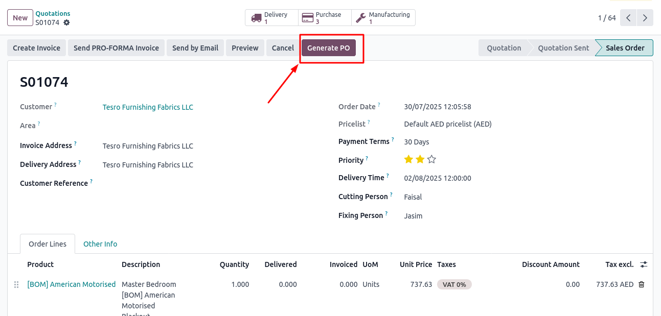

* After clicking this button, a new **Purchase Order** form will open.

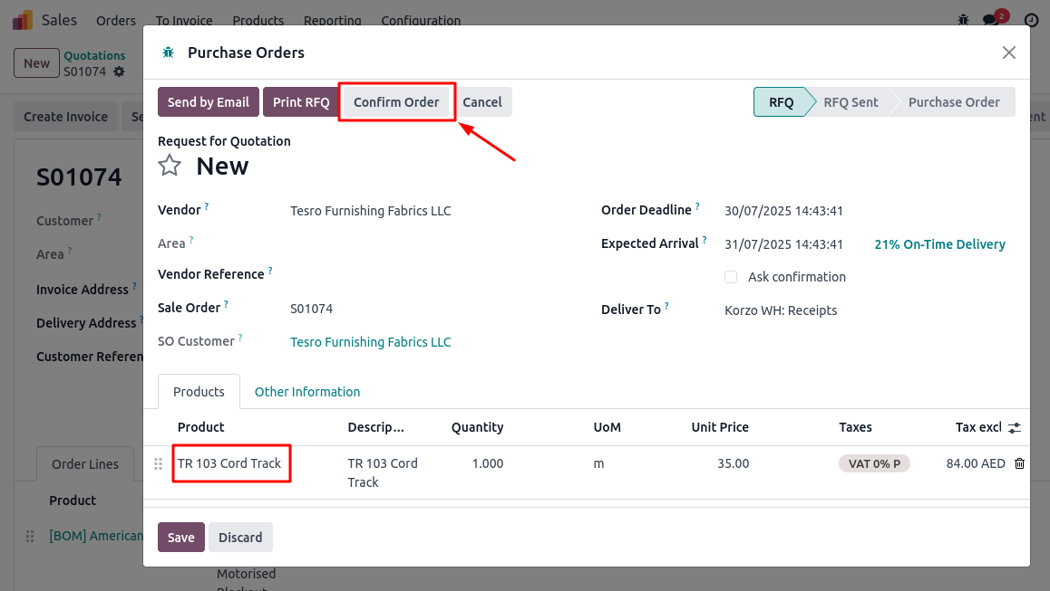

* Once the purchase order is confirmed, it will appear under the **Purchase Orders** smart button on the related **Sale Order**.

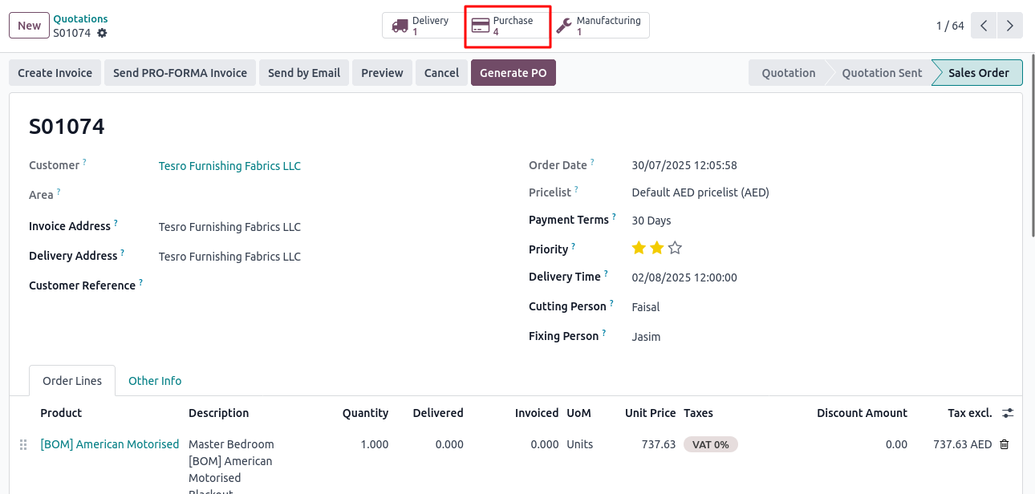

* If the user has the **“Approve Purchase Order”** permission, they will see the **“Approve Order”** button on the purchase order.
* Otherwise, the button will **not be visible**.

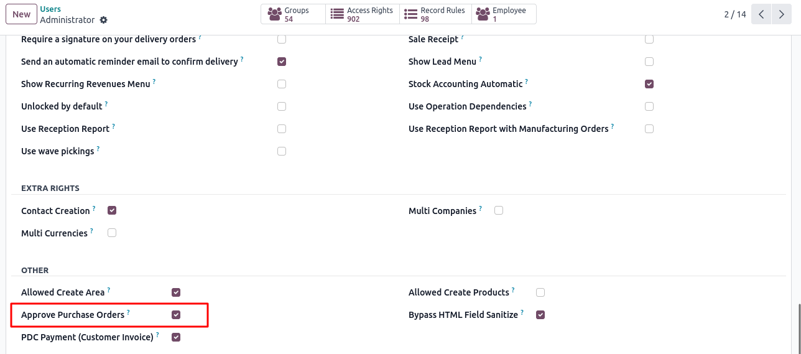

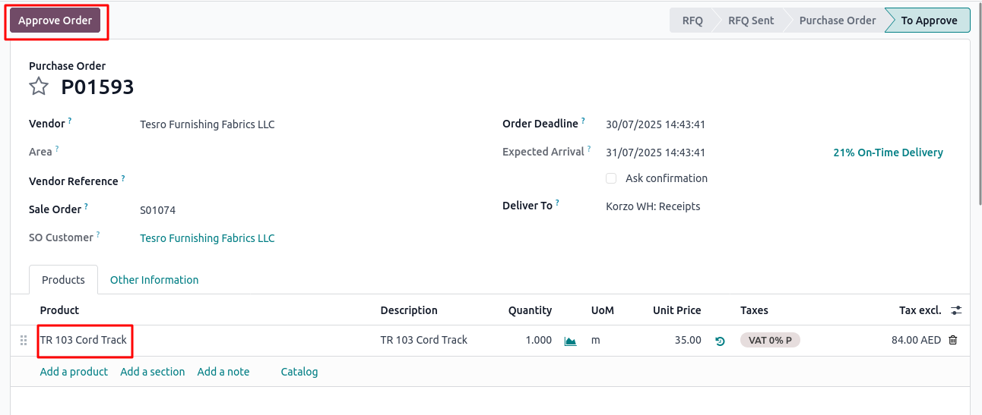

* Clicking this button will **confirm the purchase order**.
* After confirming the purchase order, its corresponding **receipt** will be visible in the **“Receipts”** app.

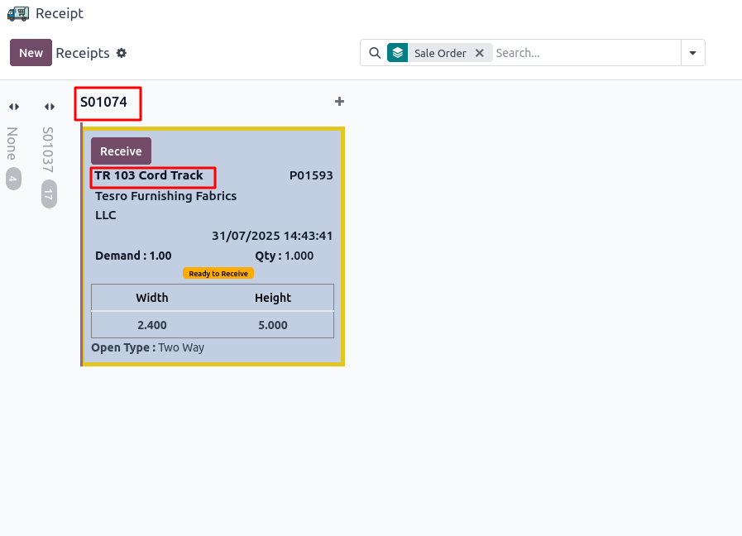

**Note:**

* When a purchase order is created using the **“Generate PO”** button, it is linked to the corresponding **sale order**.
* However, it is **not linked** to the **delivery order** or the **invoice** of that sale order.